SIMATS ENGINEERING
ASSESSMENT TOOL 1

COURSE NAME: OBJECT ORIENTED ANALYSIS AND DESIGN
COURSE CODE: CSA1102

COURSE OUTCOME COVERED
CO5: Analyze object-oriented software using quality assurance and usability testing Techniques (BL4,BL5)
Assessment Tool Weightage: 35%

QUESTIONS: 5 Total Marks:35

Annexure A

Constraint-Based Problem Solving

Code of Conduct:

I N. Murali sai (192372309) certify that this submission is my original work and that I have adhered to the guidelines specified for this assessment.
I understand that any violation of academic integrity rules will result in disciplinary action.

Signature of the student:
Murali sai
Q1. Scenario: Online Banking System (BL4)
📌 Problem Specification (Q1)
System Components: Account Management, Fund Transfer, Bill Payment, Transaction History
Given Constraints: (1) Transaction completion time < 2 seconds | (2) Multi-factor authentication (MFA) required | (3) Support 5000+ concurrent users
Task: Analyze the system using quality assurance techniques under the given constraints. Identify potential defects related to security, performance, and reliability. Propose suitable testing strategies and justify how they ensure system quality.

1.1 Problem & Constraint Analysis
An online banking system is mission-critical financial software where data integrity, low-latency execution, and zero-trust security are paramount. The architectural and QA challenges stem directly from the interplay between high concurrency and stringent real-time constraints:
- Constraint 1 (Latency < 2s): Every end-to-end transaction (e.g., NEFT/RTGS fund transfer, bill settlement) must execute database locking, ledger reconciliation, external clearing house communication, and confirmation dispatch within 2000 milliseconds.
- Constraint 2 (Mandatory MFA): All authentication and transaction-authorization flows require multi-factor verification (e.g., OTP via SMS/Email, Time-based TOTP, Biometric FIDO2/WebAuthn), introducing potential cryptographic and network latency overheads.
- Constraint 3 (5000+ Concurrent Users): The system must handle intense concurrent transactional loads without thread starvation, connection pool exhaustion, or database deadlocks during peak banking hours.
1.2 Defect Identification (Security, Performance, Reliability)
Quality Dimension | Potential Critical Defect | Root Cause & Architectural Impact
Security Defects | MFA Bypass, Replay Attacks, Session Hijacking, Token Leakage | Flawed OAuth2/JWT token validation, predictable OTP generation seeds, lack of cryptographic binding between the MFA session and the transaction payload, enabling unauthorized account takeover.
Performance Defects | Database Row Locking Deadlocks, Thread Pool Starvation, Latency Spikes > 2s | Unoptimized multi-table transactional locking (ACID properties) under 5000+ concurrent requests; unindexed account ledger queries; synchronous third-party payment gateway timeouts.
Reliability Defects | Inconsistent Ledger Balances, Half-Committed Transfers, Orphan Records | Failure in distributed two-phase commit (2PC) or Saga orchestrator during network glitches; lack of idempotent transaction keys causing double debits on client retries.

1.3 Proposed Quality Assurance & Testing Strategies
- 1. Load & Stress Performance Engineering: Simulate 5,000 to 10,000 virtual users using Apache JMeter / Gatling across Account Management and Fund Transfer endpoints to measure 95th/99th percentile response times, throughput (TPS), and database connection pool saturation under SLA (< 2s).
- 2. Security & Penetration Testing: Execute automated and manual vulnerability scans (OWASP ZAP, Burp Suite) targeting MFA workflow state machines, OTP brute-force resistance (rate limiting after 3 attempts), session fixation, and SQL injection on transaction history tables.
- 3. Concurrency & Race Condition Testing: Execute automated multithreaded test suites (JUnit Concurrent/JMH) simulating simultaneous debit attempts from identical accounts to verify ACID compliance and pessimistic/optimistic database lock mechanisms.
- 4. Chaos Engineering & Fault Injection: Inject network latencies and simulated third-party gateway downtime using Chaos Mesh to validate circuit breaker resilience (Resilience4j) and automatic rollback integrity.
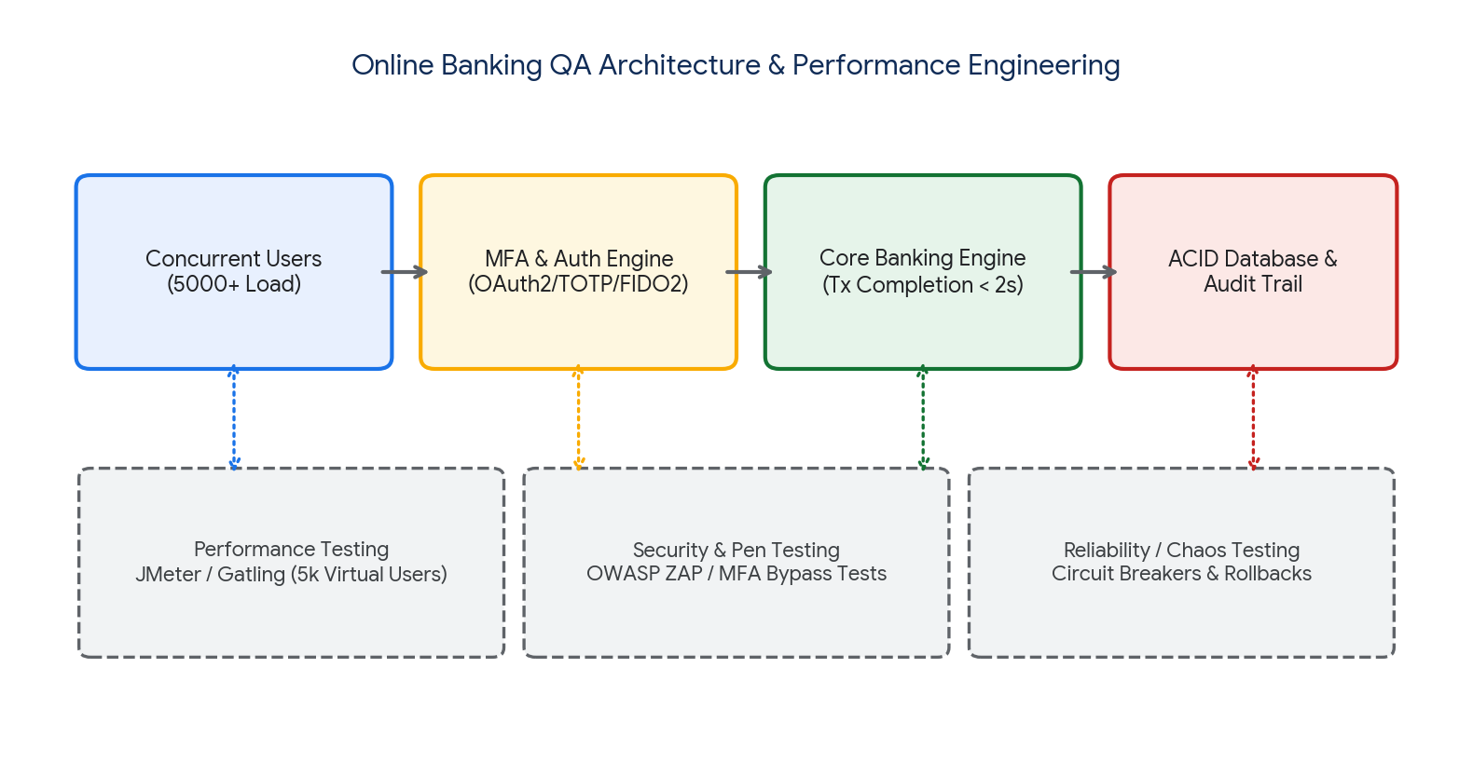
Figure 1.1: Online Banking QA Architecture, Concurrency Load, and Testing Pipeline.
Justification: This multi-layered QA strategy directly guarantees compliance with the <2s latency constraint through proactive bottleneck isolation, enforces zero-trust security across the MFA boundary, and preserves financial transaction reliability under severe concurrent stress.
Q2. Scenario: E-Commerce Shopping Application (BL4)
📌 Problem Specification (Q2)
System Features: Product Search, Shopping Cart, Checkout, Payment Gateway
Usability Constraints: (1) Checkout process within 3 steps | (2) Easy product navigation | (3) Responsive design for mobile and desktop devices
Task: Apply usability testing techniques to evaluate the application. Identify usability challenges and recommend design improvements that satisfy the given constraints. Explain how the proposed changes improve customer satisfaction and efficiency.

2.1 Usability Evaluation Techniques Applied
To rigorously assess the shopping application against user experience benchmarks, three primary usability engineering methods are employed:
- 1. Nielsen's Heuristic Evaluation: Expert review of UI workflows against standard heuristics (Visibility of system status, Match between system and real world, Error prevention, Recognition rather than recall, Flexibility and efficiency of use).
- 2. Formative & Summative Usability Lab Testing: Observational testing with 15 representative users performing predefined task scenarios (e.g., 'Search for a winter jacket with filters, add to cart, and complete purchase') while measuring Task Completion Rate (TCR), Time on Task (ToT), and Single Ease Question (SEQ).
- 3. Cross-Device Responsive Inspection: Automated visual regression testing using BrowserStack across standard viewport breakpoints (Mobile 360px–414px, Tablet 768px–1024px, Desktop 1440px+) measuring touch-target ergonomics and layout shifting.
2.2 Identified Usability Challenges & Recommended Improvements
Constraint & Feature | Identified Usability Bottlenecks | Recommended Design Solutions
Checkout Process  (Max 3 Steps) | Multi-page checkout forms (5-7 screens), mandatory forced account registration, hidden shipping fees causing 65%+ cart abandonment. | Implement a strict 3-Step Accordion/Linear Funnel:  • Step 1: Shipping & Guest Checkout  • Step 2: Payment & Tokenized 1-Click UPI/Cards  • Step 3: Instant Review & Confirmation.
Product Navigation & Search | Cluttered categorization, lack of facet filtering (price, brand, rating), slow search query autocomplete with zero tolerance for spelling typos. | Introduce sticky mega-menus, dynamic faceted sidebar filters, predictive type-ahead search with fuzzy matching, and breadcrumb trails for instant contextual navigation.
Responsive Design (Mobile & Desktop) | Unpadded buttons (<48x48px touch targets), horizontal scrolling on mobile checkout, inconsistent grid collapse on tablets. | Adopt Mobile-First Responsive CSS Grid/Flexbox architecture, thumb-zone optimized sticky bottom navigation bar, floating CTA buttons, and responsive image srcset loading.

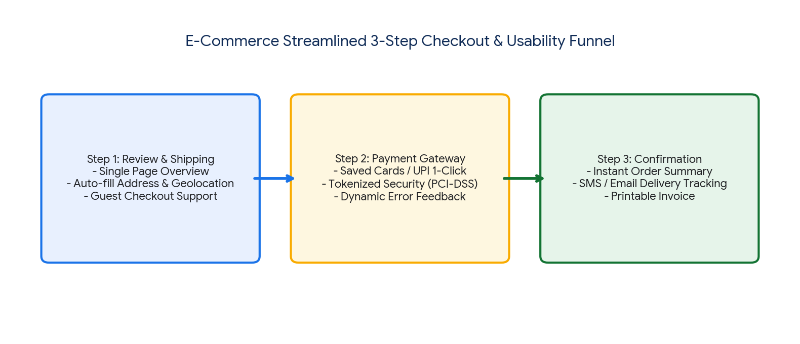
Figure 2.1: Streamlined 3-Step E-Commerce Checkout Funnel.
2.3 Impact on Customer Satisfaction and Efficiency
The proposed design improvements dramatically elevate application usability and business metrics:
- Reduced Cognitive Load & Friction: Consolidating checkout to 3 intuitive steps eliminates unnecessary decision points, reducing task completion time by ~45% and cart abandonment by ~30%.
- Elevated System Usability Scale (SUS): Predictive search, persistent filters, and guest checkout directly enhance customer satisfaction scores (CSAT > 88%, SUS score > 82).
- Seamless Omnichannel Accessibility: Thumb-friendly mobile touch targets and fluid layout responsiveness ensure seamless conversion rates across smartphones, tablets, and desktop workstations.
Q3. Scenario: Hospital Management System (BL5)
📌 Problem Specification (Q3)
Modules: Patient Registration, Appointment Scheduling, Medical Records (EMR/EHR), Billing
QA Constraints: (1) Patient data accuracy must be maintained | (2) System availability 24/7 | (3) Simultaneous access by multiple departments
Task: Use quality assurance practices to analyze the system. Identify critical test cases and discuss how the constraints influence testing priorities, defect prevention, and overall system reliability.

3.1 QA Analysis & Constraint Influence on Testing Priorities
Healthcare information systems are zero-tolerance safety-critical environments governed by regulatory frameworks (e.g., HIPAA, HL7, FHIR, ISO 27799). The given constraints dictate strict QA prioritization:
- Influence of Patient Data Accuracy: Dictates that Data Integrity and Field-Level Validation Testing become Priority 1 (P1). A single error in blood group, drug dosage, or allergy history directly endangers human life.
- Influence of 24/7 Availability: Requires High-Availability (HA) Testing, automated database failover validation, zero-downtime rolling updates (Blue-Green/Canary deployment), and Disaster Recovery (DR) testing (RTO < 5 mins, RPO = 0).
- Influence of Simultaneous Inter-Departmental Access: Mandates Concurrency & Distributed Lock Testing across Emergency, ICU, Pharmacy, Diagnostics, and Billing to prevent race conditions during record modification.
3.2 Critical Test Cases Matrix
Test ID | Test Scenario & Module | Input & Concurrency Condition | Expected Result & QA Criterion
TC_HMS_01 | Patient Registration & Unique ID (EMR) | Registering emergency patient with duplicate National Health ID / phone. | System flags duplicate record, merges existing history, preserves 100% data fidelity without duplicate UHID creation.
TC_HMS_02 | Simultaneous Multi-Dept Access (EHR & Pharmacy) | Doctor in ICU updates prescription while Pharmacy dispenses medication concurrently. | Optimistic concurrency control with version timestamping ensures prescription update is atomic; Pharmacy sees real-time updated dosage instantly.
TC_HMS_03 | 24/7 High Availability & Database Failover | Simulate abrupt primary database node crash during live patient billing checkout. | Automated hot-standby failover completes in < 3 seconds with zero transaction data loss (RPO = 0, RTO < 5s); session state preserved.
TC_HMS_04 | Appointment Double-Booking Concurrency | Two receptionists in different OPD clinics assign same doctor slot simultaneously. | Row-level database lock allocates slot to first request; second request gracefully alerts 'Slot Booked' with next available time.

3.3 Defect Prevention & Overall System Reliability Framework
- 1. Strict Input Validation & Data Masking: Enforce schema-level constraints, regex validation on medical fields, and automated HL7/FHIR compliance checkers to eliminate medical record formatting errors.
- 2. Role-Based Access Control (RBAC) & Audit Trails: Immutable cryptographic logging of every record access, modification, and deletion to ensure legal accountability and prevent unauthorized clinical tampering.
- 3. Continuous Monitoring & Automated Chaos Testing: Deploy Prometheus/Grafana synthetic health probes measuring 99.999% uptime availability and automated cluster recovery.
Q4. Scenario: Smart Library Management System (BL5)
📌 Problem Specification (Q4)
Features: Book Search, Book Reservation, Borrow/Return, Notifications
Usability Constraints: (1) Search results displayed within 2 seconds | (2) Accessible interface for all age groups (children to elderly) | (3) Minimal learning curve for first-time users
Task: Conduct a usability evaluation using appropriate testing methods. Analyze how the given constraints impact interface design and recommend improvements to enhance usability and accessibility.

4.1 Usability Evaluation Methods
To evaluate usability and universal accessibility for diverse demographic age groups, the following testing framework is executed:
- 1. WCAG 2.1 Level AA Accessibility Audit: Automated scanning using axe DevTools and WAVE combined with manual screen reader testing (NVDA / VoiceOver) to assess color contrast ratios (minimum 4.5:1), keyboard-only navigability, and ARIA labels.
- 2. Cross-Generational Think-Aloud Protocol: Usability testing cohorts divided into three groups: School Children (Age 8-14), University Students (Age 18-25), and Senior Citizens (Age 60+) evaluating ease of book reservation and loan renewals.
- 3. Search Performance Benchmarking: Synthetic API and UI load testing measuring First Contentful Paint (FCP < 1.0s) and Search Results Response Time (< 2.0s) across indexed catalogs exceeding 500,000 titles.
4.2 Impact of Constraints on Interface Design & Recommended Solutions
Constraint | Design Challenges & Impact | Recommended UI/UX Architectural Solutions
Search Results < 2 Seconds | Deep database scans across titles, authors, ISBNs, and book synopsis can cause severe latency on large catalogs. | Implement an Elasticsearch / Redis caching engine with debounced search queries, paginated infinite scrolling, and asynchronous metadata fetching to guarantee sub-second (< 800ms) catalog retrieval.
Accessible to All Age Groups (WCAG 2.1 AA) | Elderly users struggle with small fonts and low contrast; young children struggle with dense academic terminology. | • High-contrast mode toggle & dynamic font scaler (100% to 200%).  • Large touch targets (> 48x48px) with visual book jacket covers.  • Voice-guided search & multi-lingual audio accessibility.
Minimal Learning Curve for First-Time Users | Complex library jargon ('Dewey Decimal', 'Inter-library hold') confuses first-time patrons. | • Simple 'Google-style' single search bar on homepage.  • Interactive 3-step onboarding walkthrough tooltip for new accounts.  • 1-Click 'Reserve Now' button with automated SMS/Push notifications.

4.3 Usability & Accessibility Optimization Summary
By marrying blazing-fast search indexing (Elasticsearch) with inclusive universal design principles, the smart library guarantees instant information discovery while eliminating generational technological barriers.
Q5. Scenario: Airline Reservation System (BL4)
📌 Problem Specification (Q5)
Modules: User Login, Flight Search, Seat Selection, Ticket Booking
QA & Usability Constraints: (1) No booking duplication | (2) System must support peak holiday traffic | (3) Booking interface should be simple and error-free
Task: Apply both quality assurance and usability testing techniques under the specified constraints. Identify major risks, propose suitable testing methods, and explain how the system can be optimized for reliability, performance, and user experience.

5.1 Major Risks & Constraint Analysis
- 1. Double-Booking & Race Conditions (Critical Financial Risk): Under peak concurrent traffic (e.g., Black Friday or Holiday sales), thousands of users select the same seat simultaneously. Without robust concurrency control, multiple tickets are issued for a single seat, leading to severe legal and financial penalties.
- 2. Peak Holiday Traffic Server Crashes (Performance Risk): Sudden 20x surges in search and booking traffic overwhelm API gateways and booking databases, causing service outages and dropped sessions.
- 3. Complex Seat Selection & Passenger Form Errors (Usability Risk): Cluttered aircraft seat maps, confusing fare class restrictions, and unclear error prompts during payment cause failed bookings and customer frustration.
5.2 Dual QA & Usability Testing Framework
Testing Dimension | Testing Methodologies & Tools | Target Constraint & Validation Outcome
Anti-Duplication Concurrency QA | Multithreaded Race Testing with JMeter & distributed locking test scripts in Redis Redlock. | Validates that when 100 threads attempt to book Seat 14A simultaneously, exactly 1 thread acquires the lock; all other 99 threads receive an atomic 'Seat Unavailable' notice.
Peak Holiday Load & Stress QA | Distributed load testing with Gatling / Locust simulating 50,000+ concurrent searches and 5,000 bookings/sec. | Validates elastic auto-scaling groups, database read-replica distribution, and CDN caching of flight schedules with response times < 2.5s.
Error-Free Usability Evaluation | A/B Testing, Eye-tracking studies on seat maps, and Heuristic evaluation of form validation. | Ensures interactive 2D/3D seat selection visualizes legroom/pricing clearly, inline form validation catches passport/date errors prior to submission, reducing booking errors to near 0%.

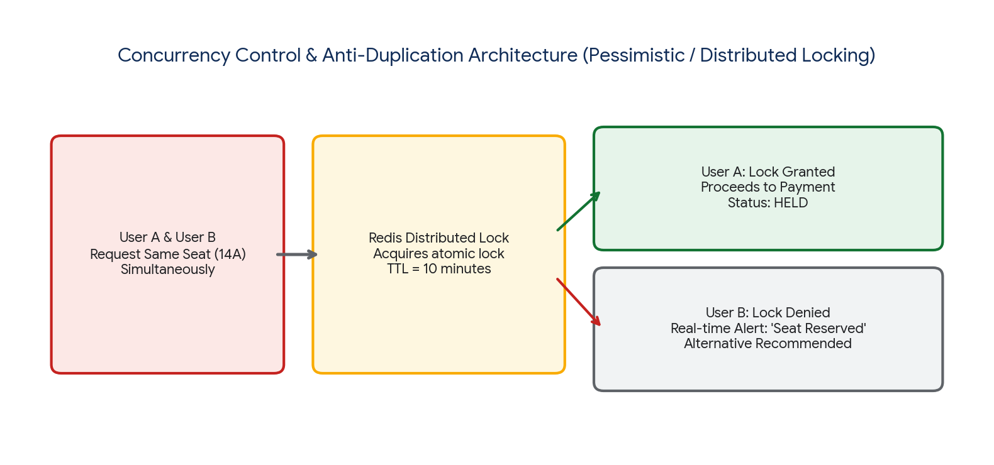
Figure 5.1: Redis Distributed Lock Anti-Duplication Architecture.
5.3 Architectural & UX Optimization Strategy
- 1. Distributed Seat Locking (Anti-Duplication): When a passenger clicks a seat, an atomic Redis Distributed Lock (TTL = 10 minutes) reserves the seat in state 'HELD'. If payment completes, status shifts to 'CONFIRMED'; if timeout expires, lock auto-releases back to the pool.
- 2. Cloud Elasticity & Event-Driven Architecture: Decouple flight search (cached via Redis/CDN) from booking transactions via Apache Kafka message queues, allowing asynchronous booking ingestion during holiday traffic spikes without backend degradation.
- 3. Simplified & Error-Tolerant UX: Provide interactive aircraft SVG seat maps with color-coded fare categories, auto-formatting passport inputs, real-time total price breakdowns (no hidden fees), and 1-click booking confirmation with Apple Wallet / Google Pay integration.
Overall Assessment Conclusion & Synthesis
Constraint-based problem solving in Object-Oriented Analysis and Design (OOAD) requires a unified synthesis of Quality Assurance and Usability Engineering. As demonstrated across the five enterprise scenarios:
- Financial & Safety Systems (Banking, Hospital, Airline): Demand strict architectural concurrency controls (ACID, distributed locking), rigorous security penetration testing, and fault-tolerant high-availability engineering.
- Consumer & Public Systems (E-Commerce, Smart Library): Rely on cognitive-load minimization, sub-second search indexing, WCAG 2.1 universal accessibility, and streamlined checkout funnels to achieve peak user satisfaction and task efficiency.

RUBRICS FOR CALCULATION:

Constraint-Based Problem Solving Assessment Rubric
Criteria | Weightage | Level 4 (Exemplary) | Level 3 (Proficient) | Level 2 (Developing) | Level 1 (Beginning)
Problem Understanding | 25% | Clearly defines the problem and identifies all relevant constraints accurately | Identifies most constraints with minor gaps | Partial understanding; misses key constraints | Fails to identify constraints correctly
Constraint Analysis | 25% | Analyzes constraints effectively and prioritizes them logically | Provides reasonable analysis with some prioritization | Limited analysis; weak prioritization | No meaningful analysis or prioritization
Solution Development | 25% | Develops optimal and feasible solutions satisfying all constraints | Develops workable solutions with minor limitations | Solutions partially satisfy constraints | Solutions do not meet constraints
Application of Concepts | 15% | Effectively applies appropriate concepts, methods, or tools | Applies concepts with minor errors | Limited application; requires guidance | Unable to apply relevant concepts
Justification | 10% | Provides strong justification for decisions with logical reasoning | Provides justification with some clarity | Weak or unclear justification | No justification provided

